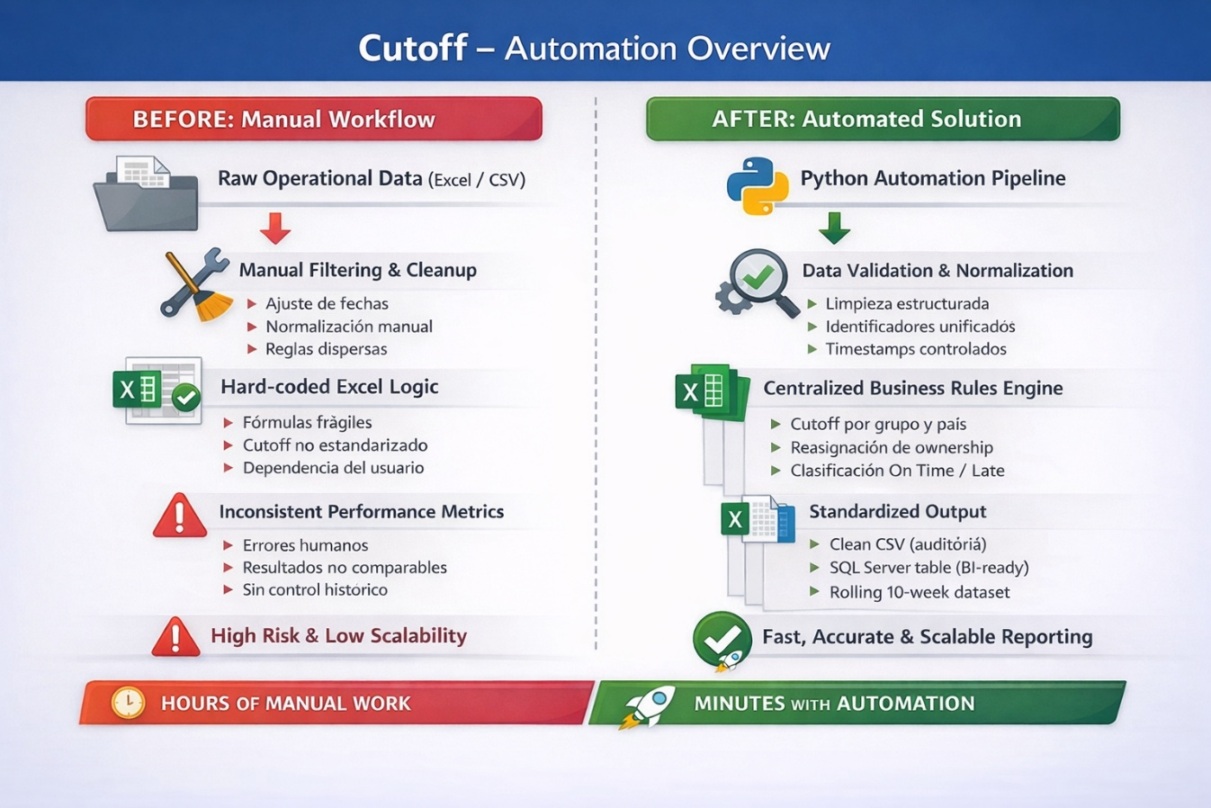
Executive Summary (Non-Technical)
This solution automates the evaluation and reporting of operational performance based on order creation timing.
It consolidates raw operational data, applies standardized business rules, identifies late vs on-time execution, and delivers a clean, validated dataset ready for analytics and executive reporting.
The automation replaces a fragmented, manual process with a reliable, repeatable pipeline that ensures consistency, accuracy, and traceability across reporting cycles.

Who Is This For
- Operations Managers
- Supply Chain & Logistics Teams
- Regional or Country Operations Leads
- Business Intelligence teams consuming SQL-based datasets

Problem Statement
Operational performance tracking was:
- Highly manual and time-consuming
- Dependent on multiple unaligned data sources
- Prone to human error (cutoff times, ownership, status calculation)
- Inconsistent across countries, groups, and reporting weeks
- Not scalable for historical or rolling-week analysis
This resulted in unreliable performance metrics and limited visibility into execution delays.

Solution Overview
A fully automated data pipeline was built to:
- Extract operational and buyer reference data
- Normalize identifiers and timestamps
- Apply standardized cutoff rules by group and country
- Assign operational ownership when automated users are detected
- Classify each record as On Time or Late
- Persist results into a SQL Server table for analytics and dashboards
The solution runs end-to-end with no manual intervention.

Before / After
Before
- Manual Excel manipulation
- Hard-coded filters and formulas
- No consistent cutoff logic
- No historical control or week filtering
- High dependency on specific users
After
- Automated, rule-driven processing
- Centralized cutoff and ownership logic
- Consistent status calculation
- Rolling 10-week controlled loads
- SQL-ready output for reporting tools

Business Rules & Logic
- Only relevant order types are evaluated
- Only operational weeks within the defined range are processed
- Cutoff times are determined by:
  - Operational group
  - Country-specific overrides
- Orders created by automated users are reassigned to responsible owners
- Status is calculated by comparing creation time vs cutoff time
- Only validated, recent data is inserted into the database
All rules are centralized and easily maintainable.

Output & Deliverables
- Clean CSV export for audit or offline review
- Structured SQL Server table for BI consumption
- Rolling-week dataset optimized for dashboards
- Execution log with timing, volume, and load traceability

Business Value
- Eliminates manual reporting effort
- Reduces operational risk and human error
- Ensures consistent KPI measurement across regions
- Enables faster decision-making with trusted data
- Scales effortlessly as volume and complexity grow

Results & Impact
- Significant reduction in reporting time
- Improved data accuracy and consistency
- Clear accountability for operational delays
- Reliable historical tracking for trend analysis
- Strong foundation for Power BI or similar dashboards

Tech Stack
- Python
- Pandas & NumPy
- SQL Server
- ODBC
- CSV & logging for traceability

My Role
- Designed the end-to-end automation architecture
- Defined and implemented business rules
- Built the data transformation and validation logic
- Optimized SQL insertion performance
- Ensured data quality, maintainability, and scalability
- Delivered a production-ready solution aligned with business needs

